Module 3: IBM Python Assignment

1. Consider a list(list=[]) and perform insertion, print, remove, append, sort, pop, reverse.

**SOLUTION:**

list = [1,2,3,4,5]

print(list)

list.insert(6,7)

print(list)

list.remove(1)

print(list)

list.append(8)

print(list)

list.sort()

print(list)

list.pop(4)

print(list)

list.reverse()

print(list)

**OUTPUT:**

[1,2,3,4,5]

[1,2,3,4,5,6]

[2,3,4,5,6]

[2,3,4,5,6,7]

[2,3,4,5,6,7]

[2,3,4,5,6]

[6,5,4,3,2]

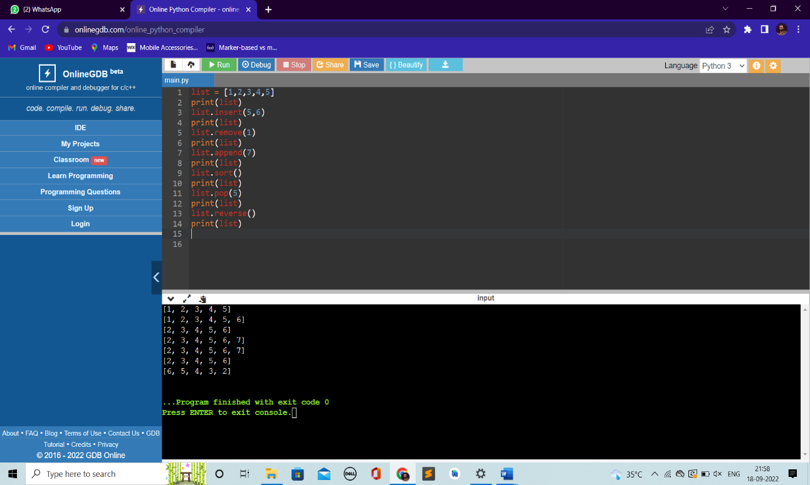

2.Write a calculator program in python.

def add(P, Q):

# This function is used for adding two numbers

return P + Q

def subtract(P, Q):

# This function is used for subtracting two numbers

return P - Q

def multiply(P, Q):

# This function is used for multiplying two numbers

return P * Q

def divide(P, Q):

# This function is used for dividing two numbers

return P / Q

# Now we will take inputs from the user

print ("Please select the operation.")

print ("a. Add")

print ("b. Subtract")

print ("c. Multiply")

print ("d. Divide")

choice = input("Please enter choice (a/ b/ c/ d): ")

num_1 = int (input ("Please enter the first number: "))

num_2 = int (input ("Please enter the second number: "))

if choice == 'a':

print (num_1, " + ", num_2, " = ", add(num_1, num_2))

elif choice == 'b':

print (num_1, " - ", num_2, " = ", subtract(num_1, num_2))

elif choice == 'c':

print (num1, " * ", num2, " = ", multiply(num1, num2))

elif choice == 'd':

print (num_1, " / ", num_2, " = ", divide(num_1, num_2))

else:

print ("This is an invalid input")

**OUTPUT:**

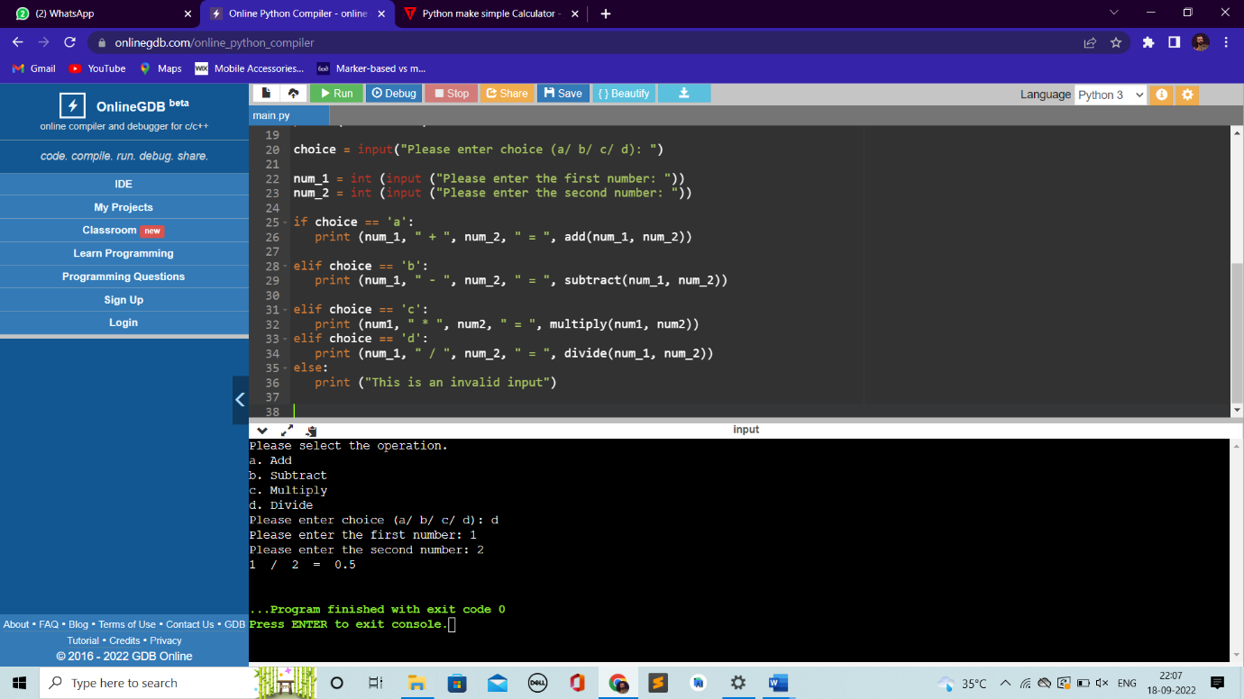

3.Write a program to concatenate, reverse and slice a string.

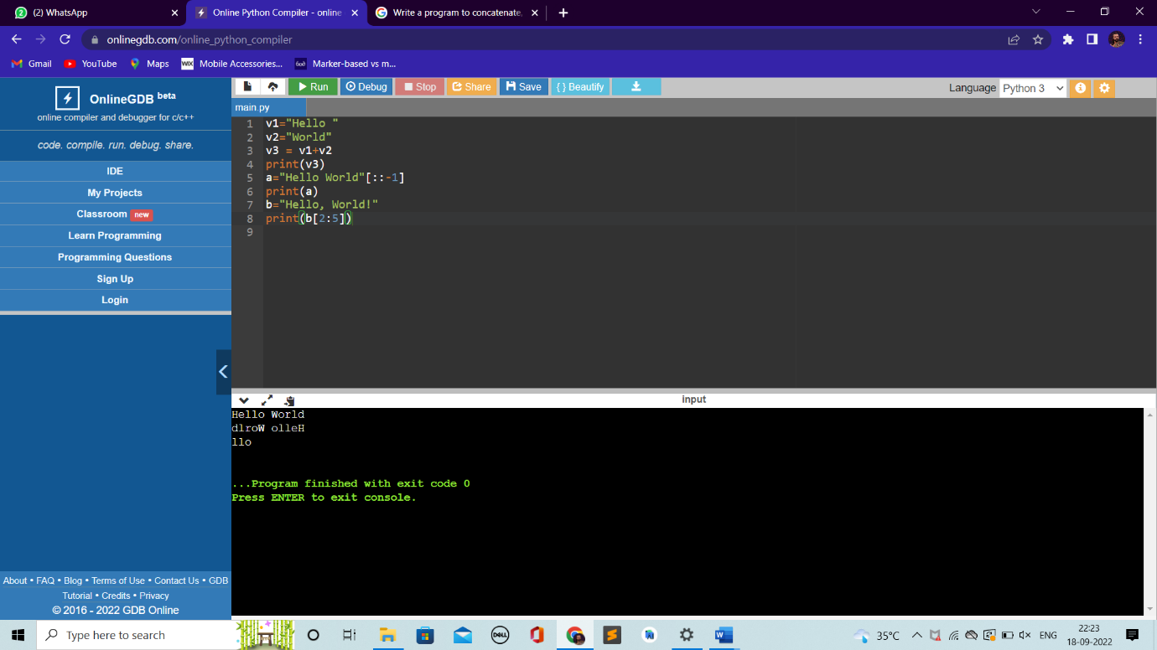

4. Why python is a popular programming language?

* Python is an interpreted, object-oriented, high-level programming language with dynamic semantics.
* Its high-level built-in data structures, combined with dynamic typing and dynamic binding, make it very attractive for Rapid Application Development, as well as for use as a scripting or glue language to connect existing components together.
* Python's simple, easy to learn syntax emphasizes readability and therefore reduces the cost of program maintenance.
* Python supports modules and packages, which encourages program modularity and code reuse. The Python interpreter and the extensive standard library are available in source or binary form without charge for all major platforms, and can be freely distributed.

5. What are the other frameworks that can be used with Python?

* Django
* Flask
* AIOHTTP
* Bottle
* Dash
* Falcon
* CubicWeb
* CherryPy

6. Full Form of WSGI?

* WSGI Stands for Web Server Gateway Interface
* **WSGI**is a specification that describes the communication between **web servers and Python web applications or frameworks**.
* It explains how a web server communicates with python web applications/frameworks and how web applications/frameworks can be chained for processing a request.